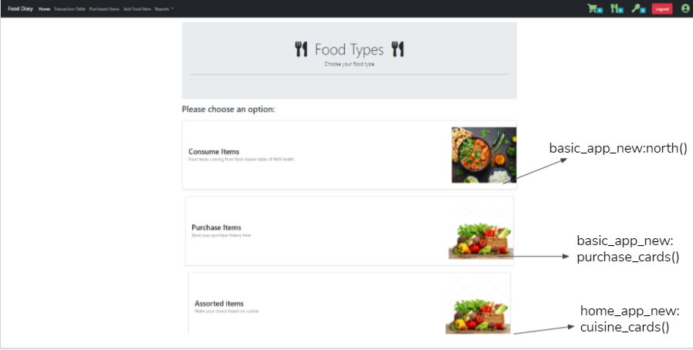

| **Method** | **Description** |
| --- | --- |
| north()  -basic_app_new | Renders the north.html template with all the food items present in the Food_diary_new table in the database with pagination |
| purchase_card()  -basic_app_new | Renders the purchase.html template with the different sections of shop names. |
| cuisine_cards()  -home_app_new | Renders the cuisine.html template with the different sections in the assorted food items like :south indian, chinese,etc where user can select from. |

**cuisine_cards.html:**

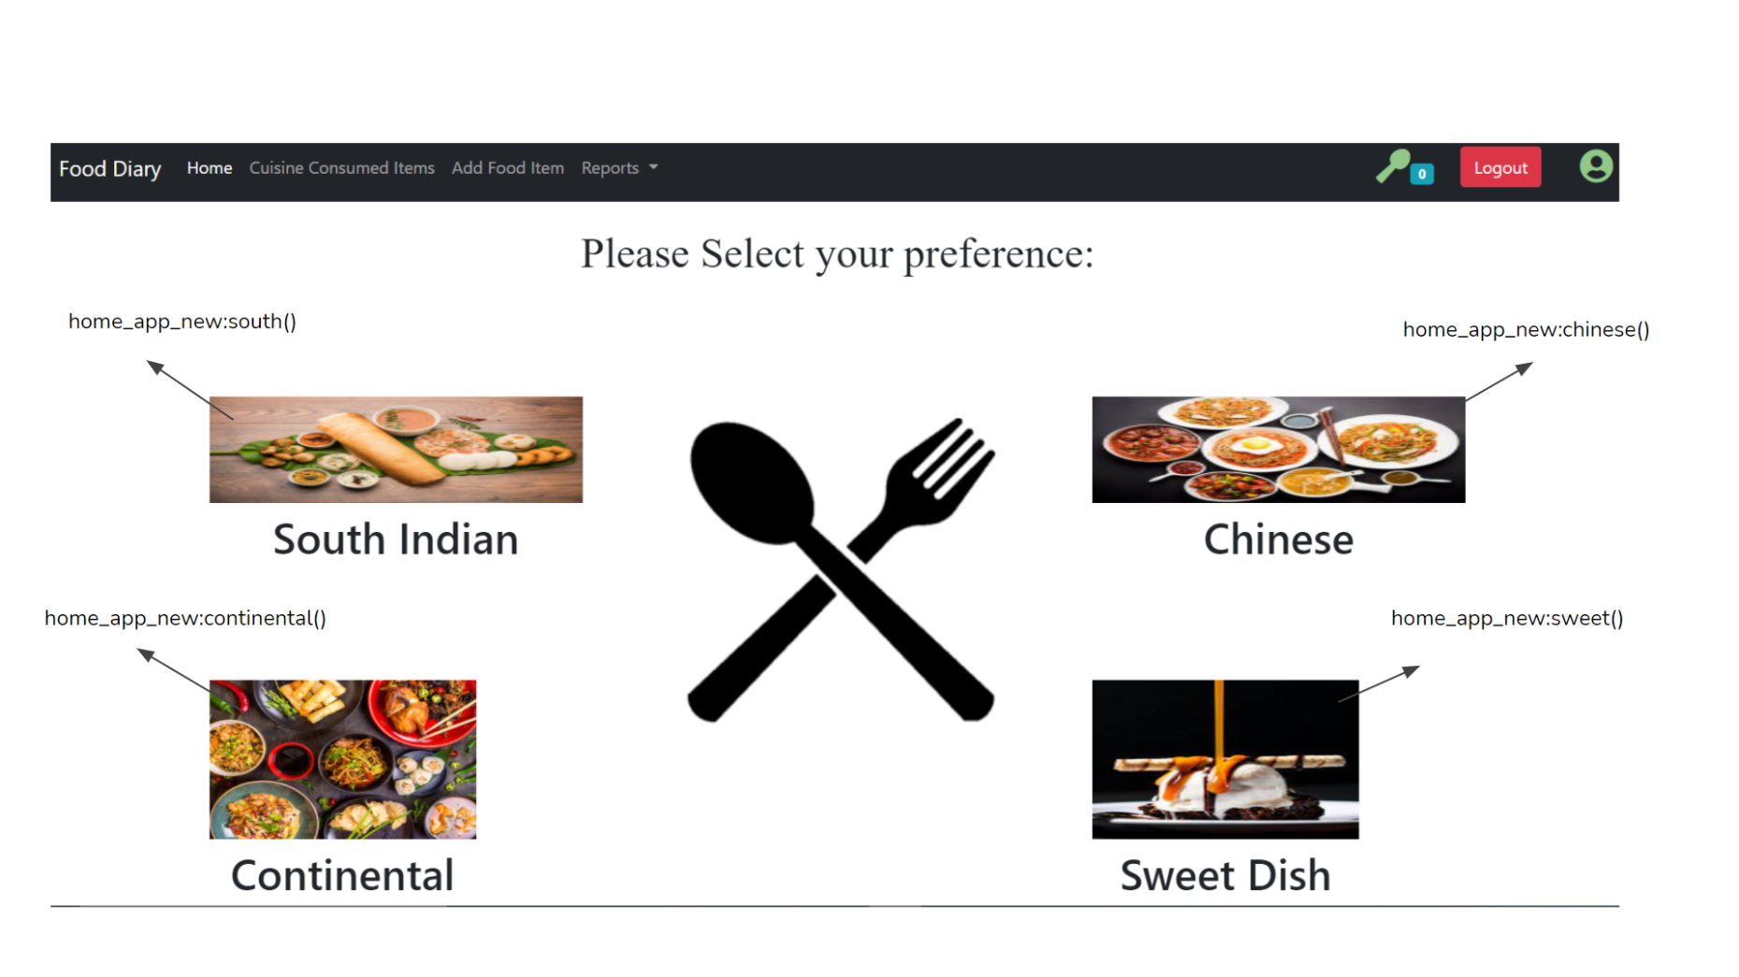

| **Method** | **Description** |
| --- | --- |
| south()  -home_app_new | Renders the assorted.html template , and passes those values in table cuisine_consumption_temp in which user_id = current user’s user_id & food_type = ‘South Indian Food’.  Also it passes all values from olf_food_diary where food_type = ‘South Indian Food’ |
| chinese()  -home_app_new | Renders the assorted.html template , and passes those values in table cuisine_consumption_temp in which user_id = current user’s user_id & food_type = ‘Chinesel’.  Also it passes all values from olf_food_diary where food_type = ‘Chinese’ |
| sweet()  -home_app_new | Renders the assorted.html template , and passes those values in table cuisine_consumption_temp in which user_id = current user’s user_id & food_type = ‘Sweet Dish’.  Also it passes all values from olf_food_diary where food_type = ‘Sweet DIsh’ |
| continental()  -home_app_new | Renders the assorted.html template , and passes those values in table cuisine_consumption_temp in which user_id = current user’s user_id & food_type = ‘Continental’.  Also it passes all values from olf_food_diary where food_type = ‘Continental’ |

**assorted.html:**

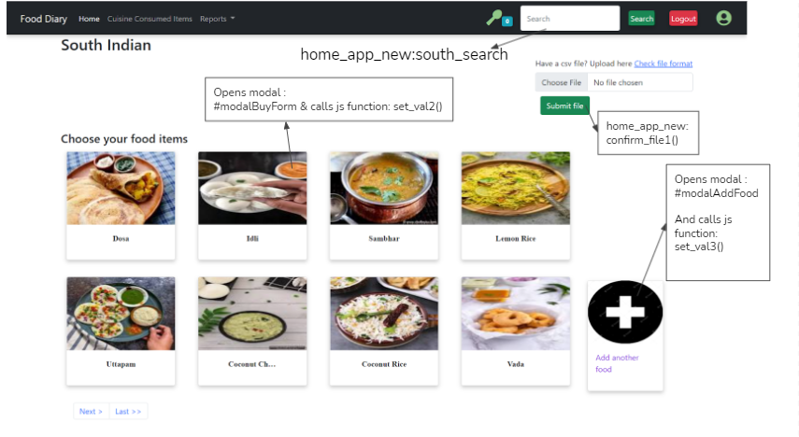

| **Method** | **Description** |
| --- | --- |
| set_val2() | Sets the current item id , item name to the respective fields. Sets quantity to 1 by default and sets the meal type according to the system time for the form in the modal #modalBuyForm. |
| set_val3() | Sets the current item id , item name to the respective fields. Sets quantity to 1 by default and sets the meal type according to the system time for the form in the modal #modalAddFood. |
| confirm_file1()  -home_app_new | Takes in csv input and converts to dataframe. Adds the values to the cusisine_consumption_temp table. |
| south_search()  -home_app_new | Renders south_search.html template.In this function it get a ‘southquery’ from search form present in the assorted.html file and returns only that food items related to the search query and food_type==South Indian Food from the Old_Food_Diary table. |

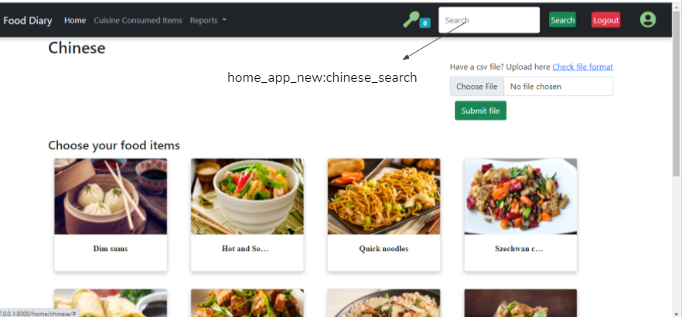

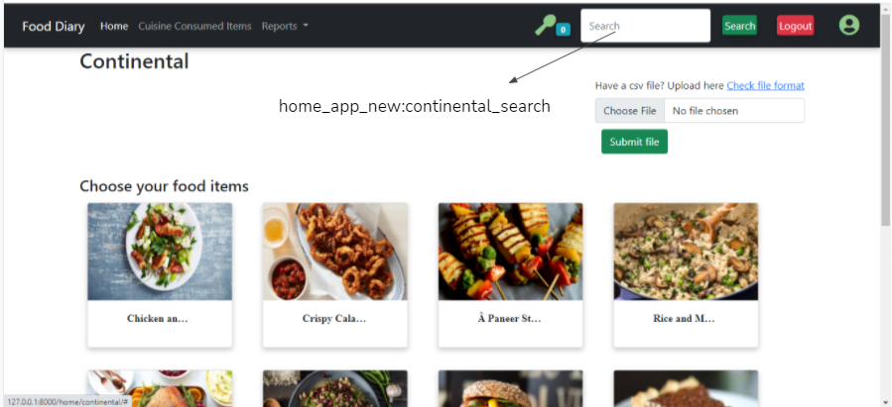

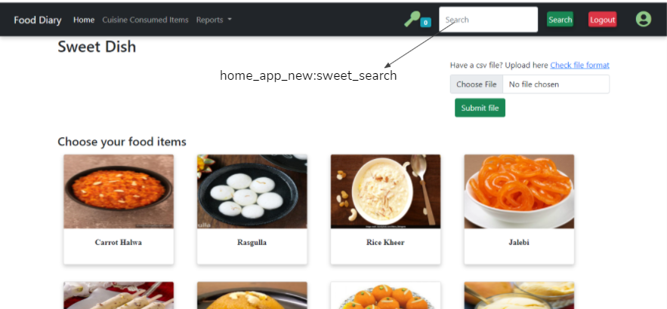

| **Method** | **Description** |
| --- | --- |
| chinese_search()  -home_app_new | Renders chinese_search.html template.In this function it get a ‘chinesequery’ from search form present in the assorted.html file and returns only that food items related to the search query and food_type==Chinese from the Old_Food_Diary table. |
| continental_search()  -home_app_new | Renders continental_search.html template.In this function it get a ‘continentalquery’ from search form present in the assorted.html file and returns only that food items related to the search query and food_type==Continental from the Old_Food_Diary table. |
| sweet_search()  -home_app_new | Renders sweet_search.html template.In this function it get a ‘sweetquery’ from search form present in the assorted.html file and returns only that food items related to the search query and food_type==Sweet Dish from the Old_Food_Diary table. |

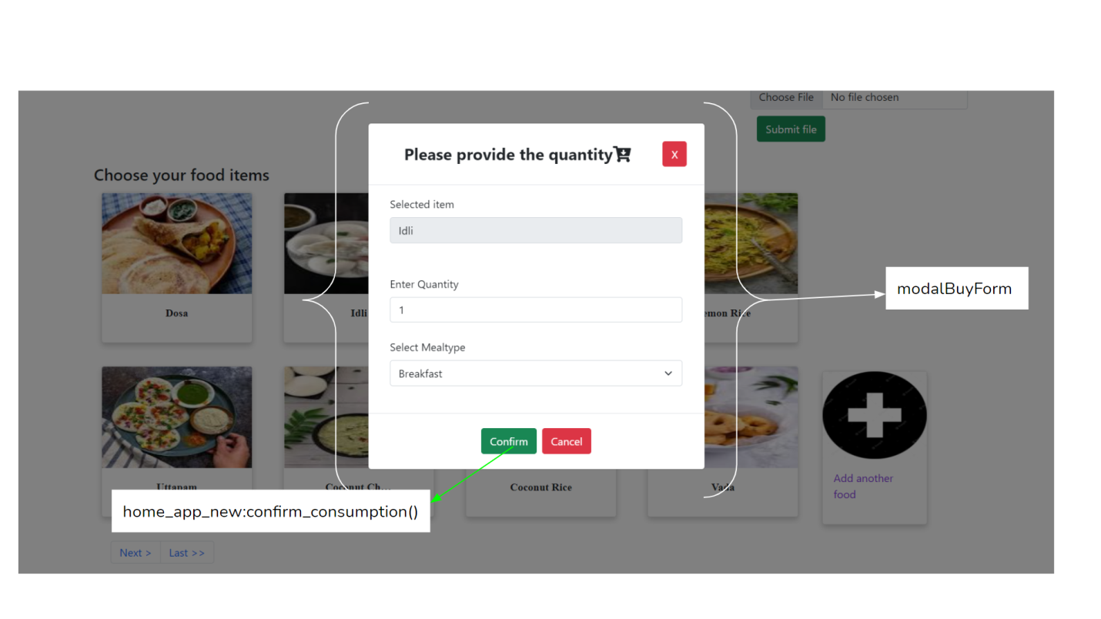

| **Method** | **Description** |
| --- | --- |
| confirm_consumption() | Takes in the form values as inputs and stores the details into cuisine_consumption_temp table. |

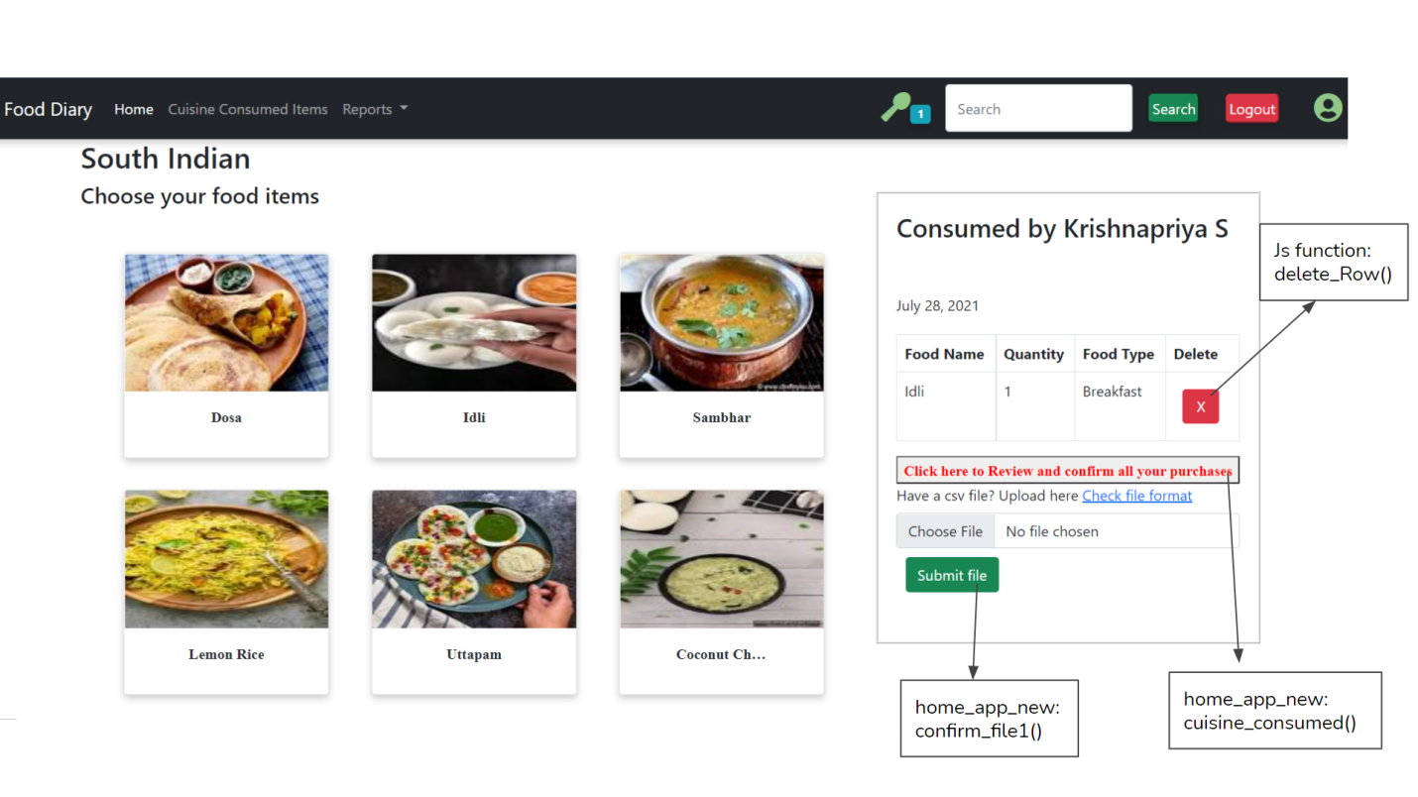

| **Method** | **Description** |
| --- | --- |
| confirm_consumption()  -home_app_new | Takes in the form values as inputs and stores the details into cuisine_consumption_temp table. |
| confirm_file1()  -home_app_new | Takes in csv input and converts to dataframe. Adds the values to the cusisine_consumption_temp table. |
| delete_Row() | A javascript function that extracts the corresponding food id of the item to be deleted and maps it to the url for the view function called delete_cusine(). |
| delete_cusisne()  -home_app_new | Delete the respective food item from the cuisine_consumption_temp table. |

**modalAddFood:**

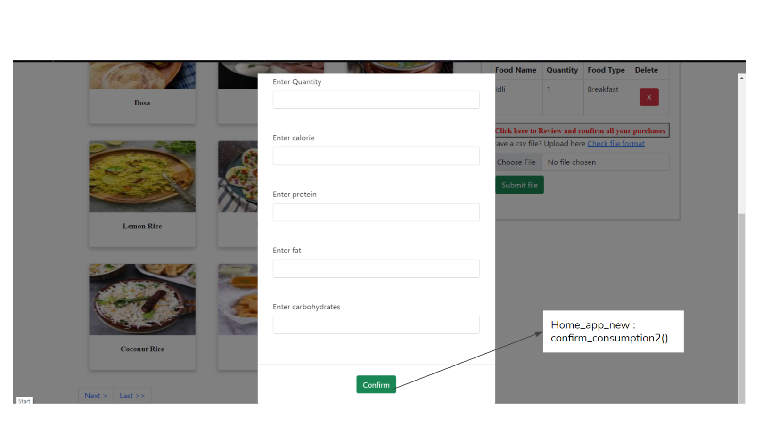

| **Method** | **Description** |
| --- | --- |
| confirm_consumption2() | Takes in the form values as inputs and stores the details into cuisine_consumption_temp table. |

**cuisine_consumed.html:**

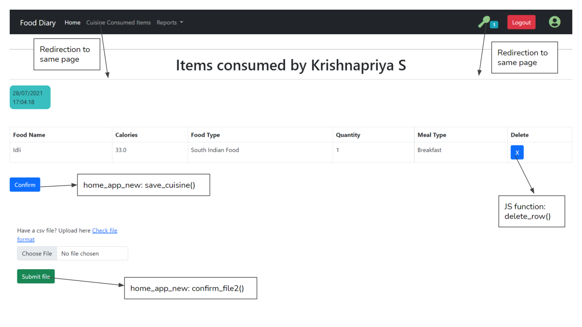

| **Method** | **Description** |
| --- | --- |
| save_cuisine()  -home_app_new | Takes all rows in cuisine_consumption temp where user_id = current user_id and appends it to cuisine_consumption_det table. Clears cuisine_consumption_temp where user_id = current user_id. |
| confirm_file2()  -home_app_new | Takes in csv input and converts to dataframe. Adds the values to the cusisine_consumption_temp table. |
| delete_Row() | A javascript function that extracts the corresponding food id of the item to be deleted and maps it to the url for the view function called delete_cusine(). |
| delete_cusisne()  -home_app_new | Delete the respective food item from the cuisine_consumption_temp table. |

**purchase_cards.html:**

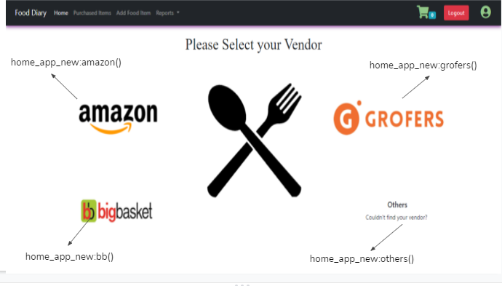

| **Method** | **Description** |
| --- | --- |
| amazon()  -home_app_new | Renders amazon.html template with all the food items related to the shop_name==amazon with pagination from the table name purchase_cards. |
| grofers()  -home_app_new | Renders amazon.html template with all the food items related to the shop_name==Grofers  with pagination from the table name purchase_cards. |
| bb()  -home_app_new | Renders amazon.html template with all the food items related to the shop_name==BigBasket with pagination from the table name purchase_cards. |
| others()  -home_app_new | Renders amazon.html template with all the food items excluding the list of shop_name {amazon,BigBasket,Grofers} with pagination from the table name purchase_cards. |

**amazon.html:**

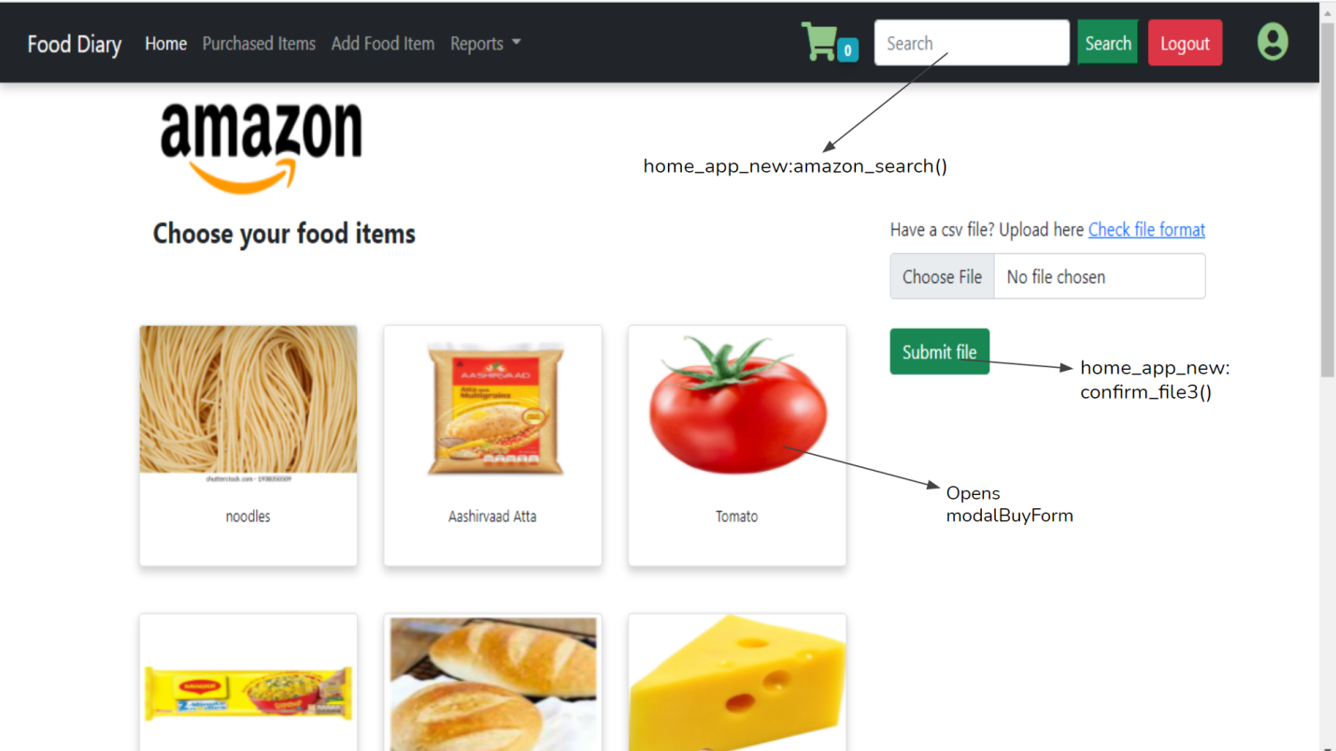

| **Method** | **Description** |
| --- | --- |
| amazon_search()  -home_app_new | Renders amazon_search.html template.In this function it get a ‘amazonquery’ from search form present in the amazon.html file and returns only that food items related to the search query and shop_name==amazon from the purchase_cards table. |
| confirm_file3()  -home_app_new | Takes in csv input and converts to dataframe. Adds the values to the temporary_purchase_new table. |

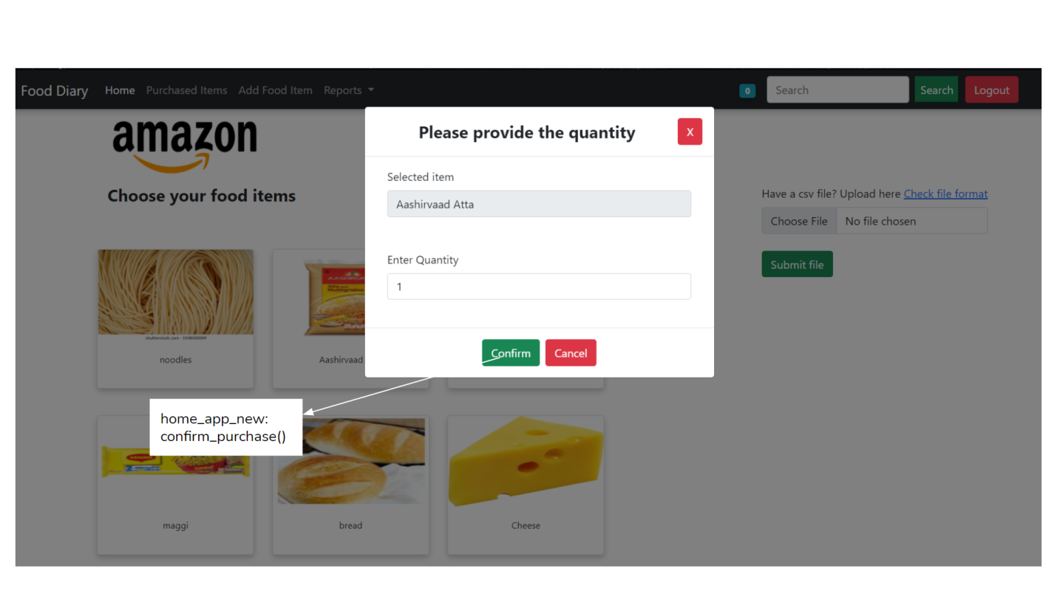

| **Method** | **Description** |
| --- | --- |
| confirm_purchase() | Takes in the form values as inputs, also fetches values via api and stores the details into temporary_purchase_new table. |

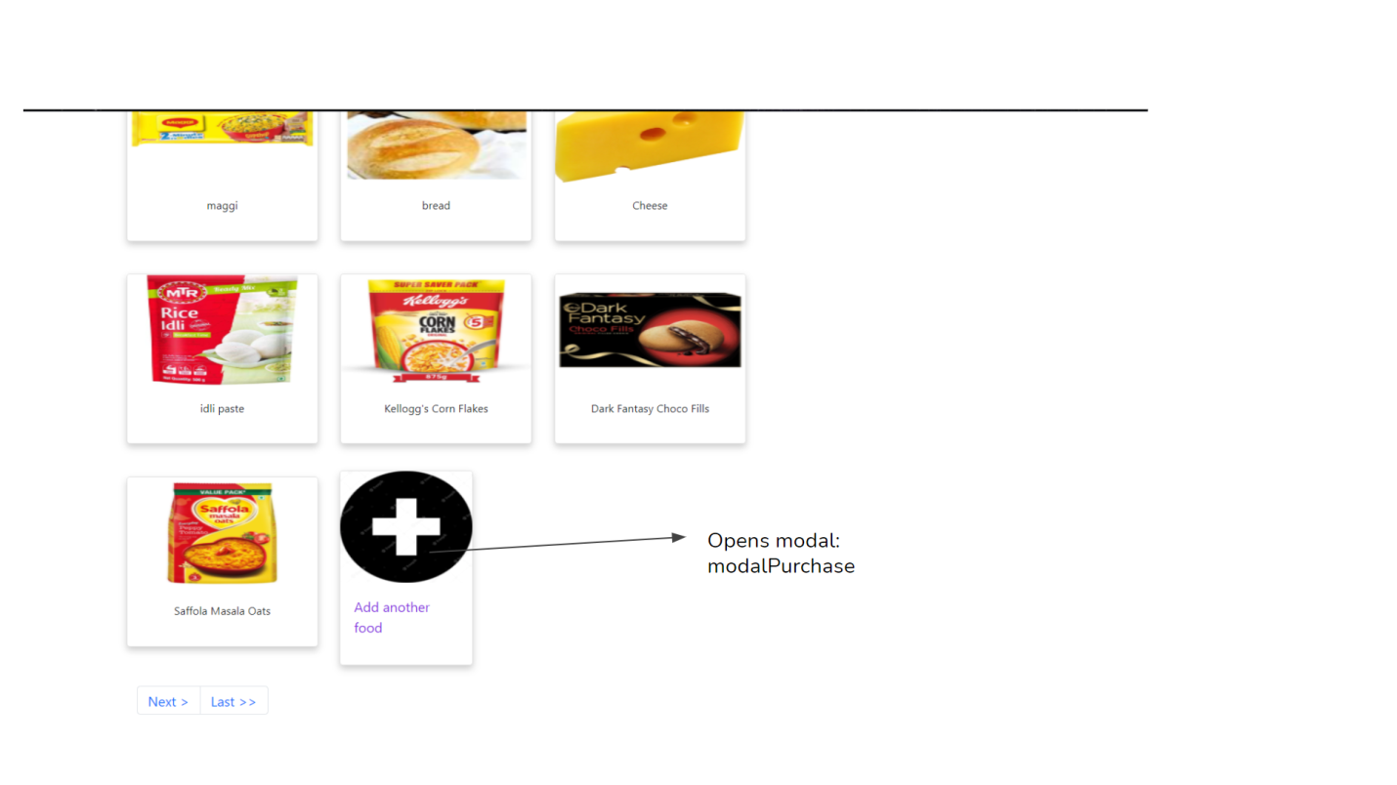

**modalPurchase:**

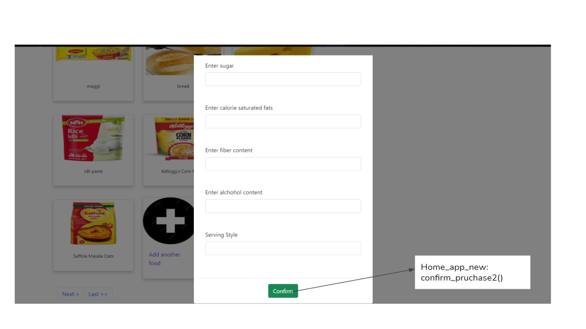

| **Method** | **Description** |
| --- | --- |
| confirm_purchase2() | Takes in the form values as inputs and stores the details into temporary_purchase_new table. |

**amazon.html:**

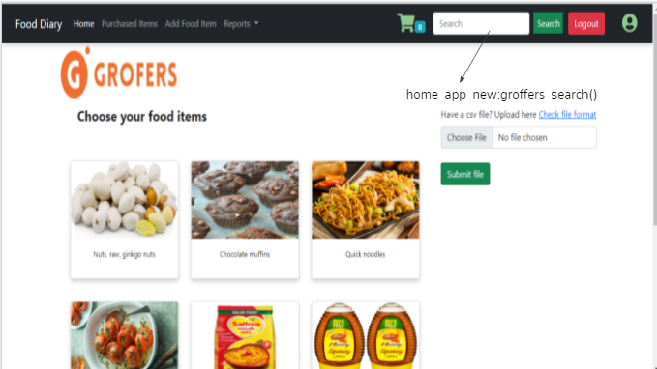

| **Method** | **Description** |
| --- | --- |
| groffers_search()  -home_app_new | Renders groffers_search.html template.In this function it get a ‘groffersquery’ from search form present in the amazon.html file and returns only that food items related to the search query and shop_name==Grofers from the purchase_cards table. |

**amazon.html:**

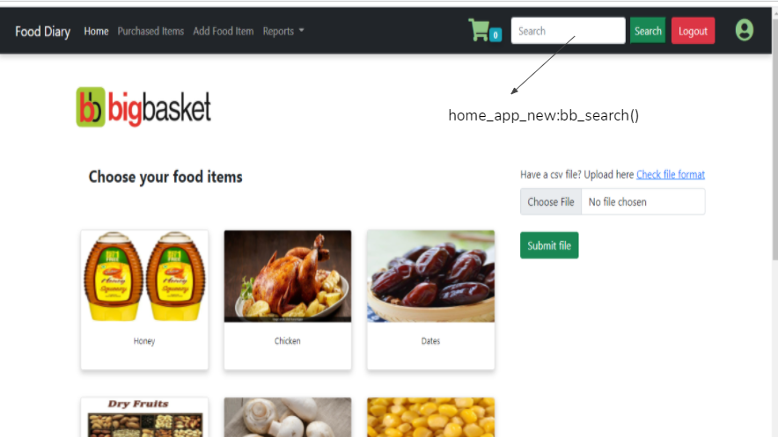

| **Method** | **Description** |
| --- | --- |
| bb_search()  -home_app_new | Renders bb_search.html template.In this function it get a ‘bbquery’ from search form present in the amazon.html file and returns only that food items related to the search query and shop_name==BigBasket from the purchase_cards table. |

**amazon.html:**

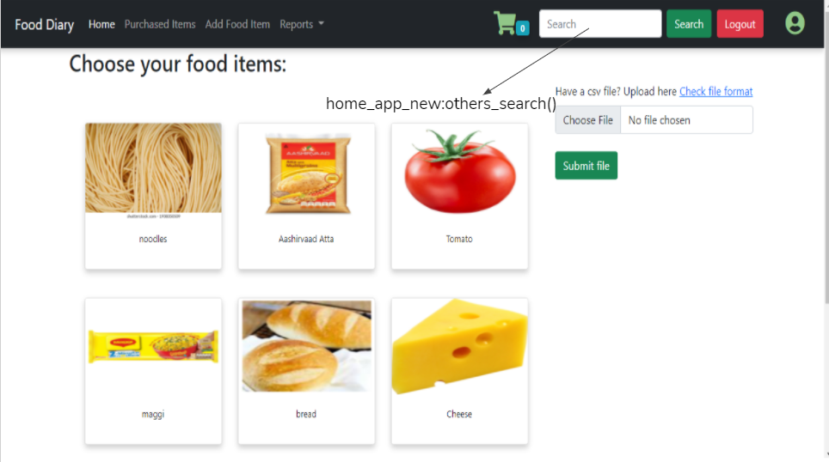

| **Method** | **Description** |
| --- | --- |
| other_search()  -home_app_new | Renders other_search.html template.In this function it get a ‘otherquery’ from search form present in the amazon.html file and returns all the food items present in the purchase_cards table. |

**north.html:**

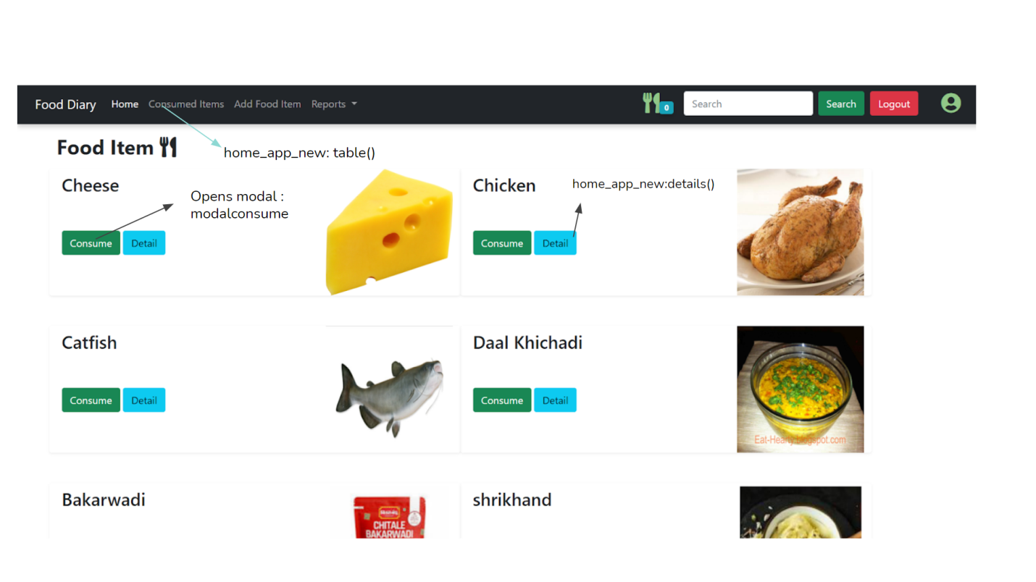

| **Method** | **Description** |
| --- | --- |
| details()  -home_app_new | Function takes in the food name as argument and calls another function get_food_details() which takes the food name as argument. Then passes the details returned by the latter to the template details.html |
| get_food_details()  -home_app_new | Calls tpancare api to fetch details of the food item using it’s food name. |

**modalconsume:**

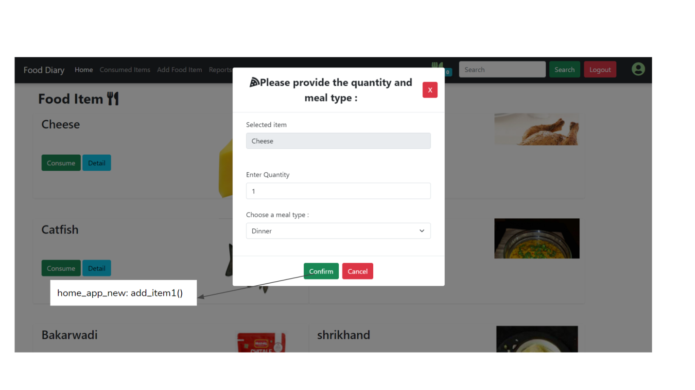

| **Method** | **Description** |
| --- | --- |
| add_item1()  -home_app_new | Takes in the form values as inputs and stores the details into temporary_transaction_new table. |

**details.html:**

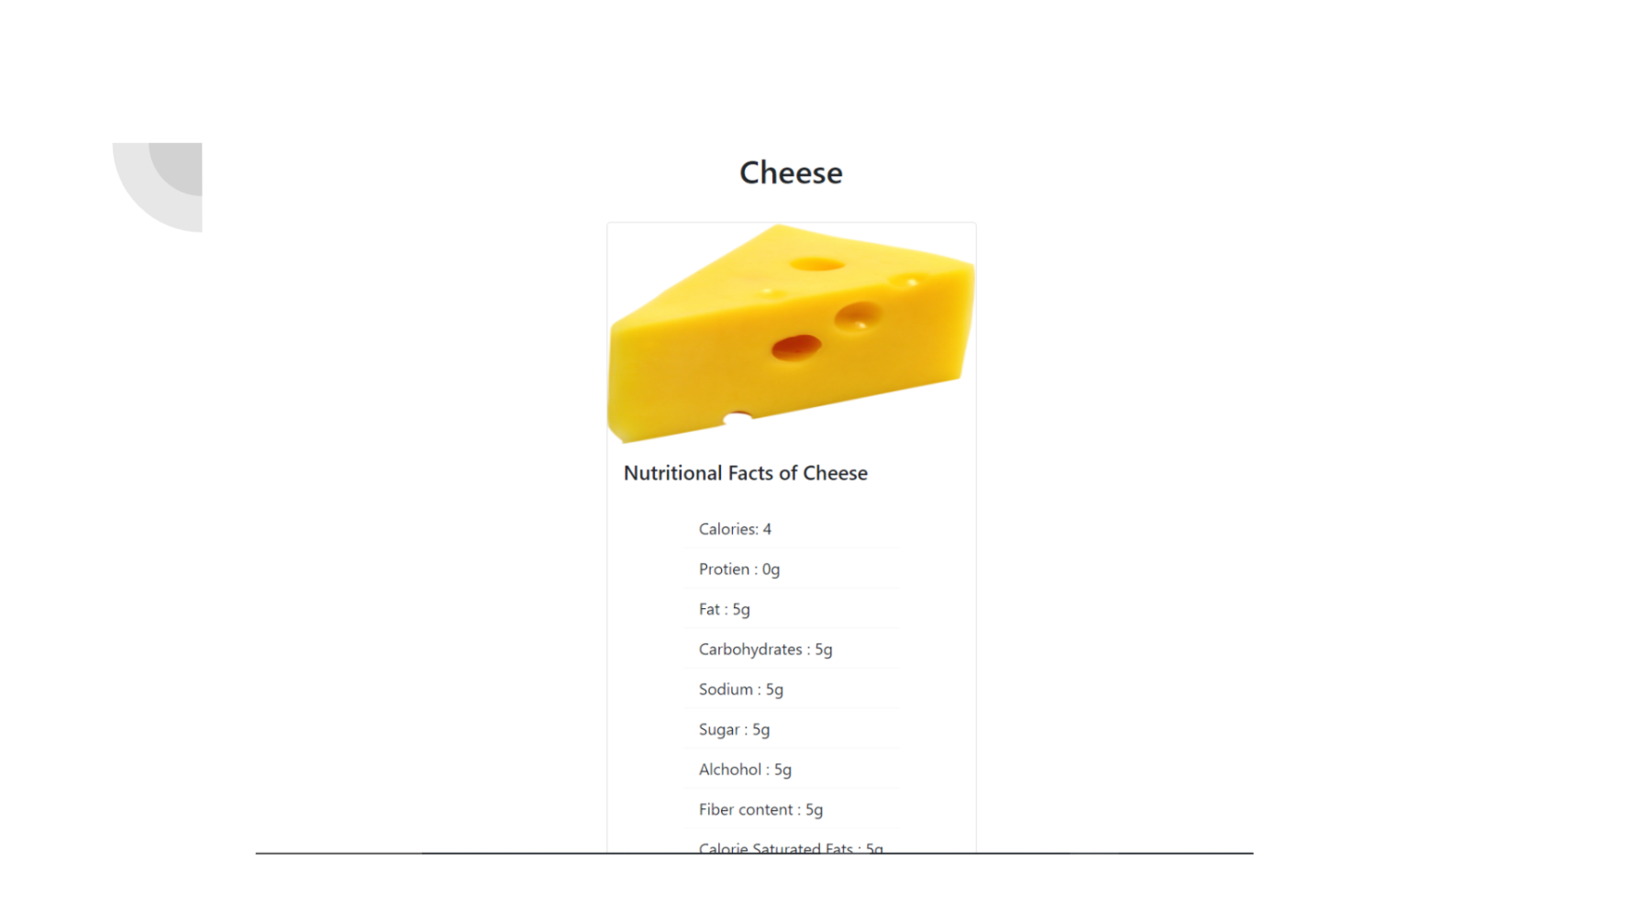

**API calling functions:**

| **Method** | **Description** |
| --- | --- |
| check_user()  -home_app_new | Calls the tpancare api to verify whether the user id and password are correct. It returns the first name and last name of the user if the user exists. |
| get_food_details()  -home_app_new | Calls the tpancare api to get the details and nutrition values of a food item from the food master table, by passing the seqid of the food item. |
| store_pancare()  -home_app_new |  |
| userfoodlogchart()  -home_app_new |  |

***Admin Login***

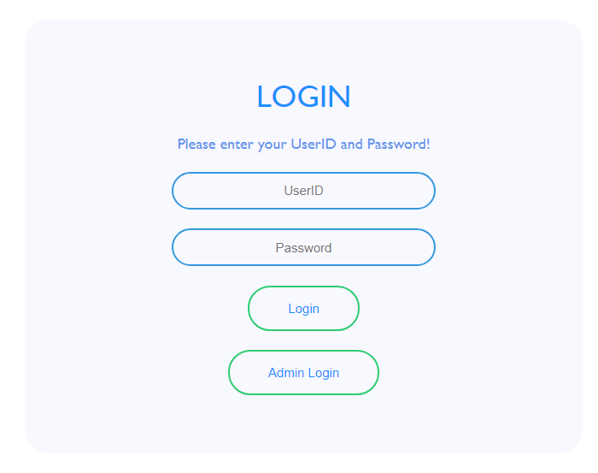

admin_page()

| **Method** | **Description** |
| --- | --- |
| FoodIndex_new: admin_page() | On clicking the “**Admin Login**” button, **admin_page()** function is called and it renders the **admin_login.html** file; redirects to **Admin Login** page |

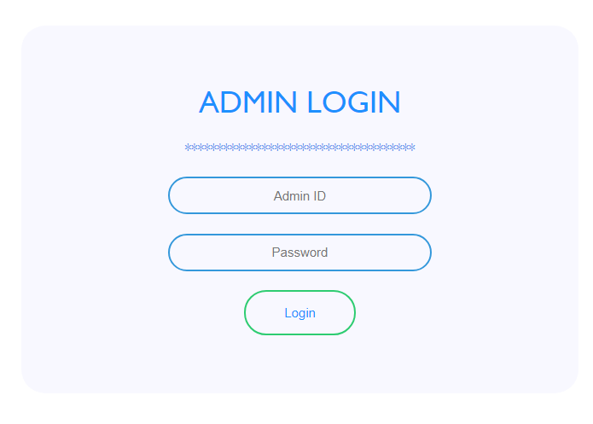

admin_login()

| **Method** | **Description** |
| --- | --- |
| FoodIndex_new: admin_login() | On clicking the “**Login**” button, **admin_login()** function is called. If the Admin Id or Password is wrong, an error message is shown: “Invalid Admin or Password”; if the data is correct, it renders the **fm_table.html** file. |

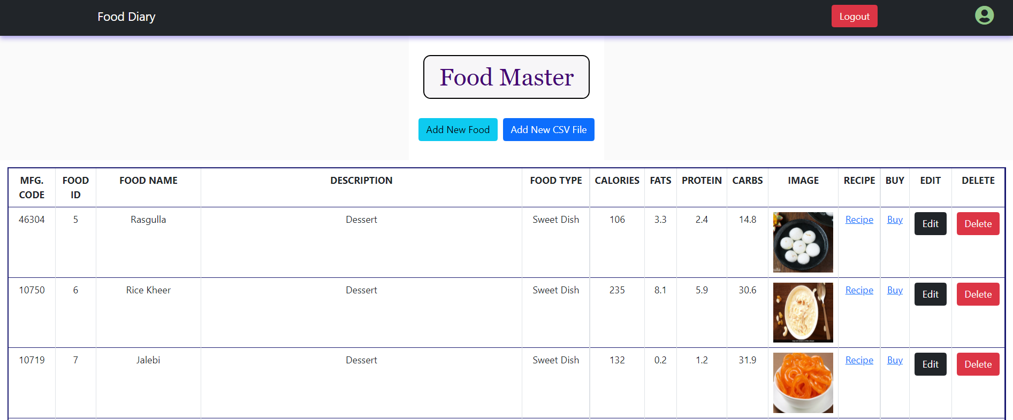

add_food()

xyz()

| **Method** | **Description** |
| --- | --- |
| Food Master Table | After successful login to admin page, the food master table appears which contains data fetched from MySQL central database. |
| “Add New Food” Button:-  FoodIndex_new: add_food() | When “**Add New Food**” is clicked, the webpage is rendered to **add_food.html** file, from which a new individual food item can be added into the database. |
| “Add New CSV File” Button:-  FoodIndex_new: xyz() | When “**Add New CSV File**” is clicked, the webpage is rendered to **upload_file.html** file, from which food items can be batch uploaded into database. |
| “Edit” button:  FoodIndex_new: update_food() | When “**Edit**” button is clicked, it renders **update_form.html** file and redirects to webpage through which the details of the food item can be modified. |
| “Delete” button:  FoodIndex_new: delete_food() | When “**Delete**” button is clicked, it deletes that item from the database. |
| “Recipe” button | On hovering over “**Recipe**”, the link to recipe can be found. |
| “Buy” button | On hovering over “**Buy**”, the link to purchase the food item can be found. |

***Add Food Item Manually***

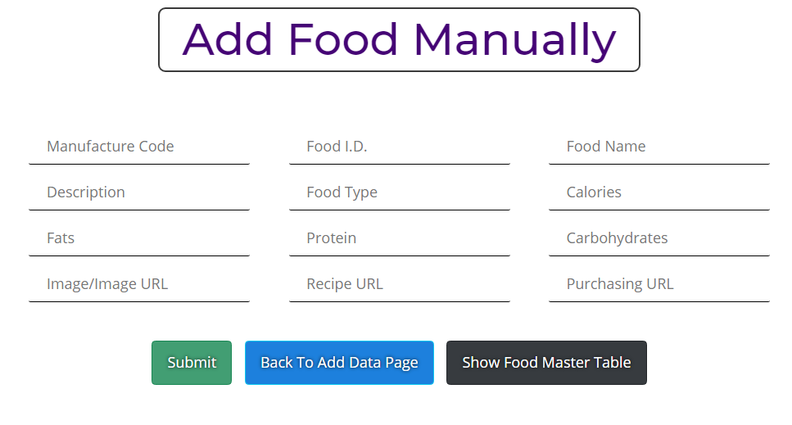

| **Method** | **Description** |
| --- | --- |
| “Add Food Manually” | When “**Add New Food**” is clicked on **Food Master Table**, this webpage is shown. Several input fields are shown. |
| “**Submit**” button:- FoodIndex_new: getdata() | When **Submit** button is called, **getdata()** function is called and the data is added into the database. Identifies data from unique **Food ID**; if duplicate is entered, it throws a warning. |
| “**Back To Add Data Page**”:- FoodIndex_new: xyz() | When **Back To Add Data Page** button is pressed, it redirects to the webpage for csv batch upload. |
| “**Show Food Master Table**”:- FoodIndex_new(): base_table() | When “**Show Food Master Table”** is pressed, it redirects to **Food Master Table.** |

***CSV Batch Upload***

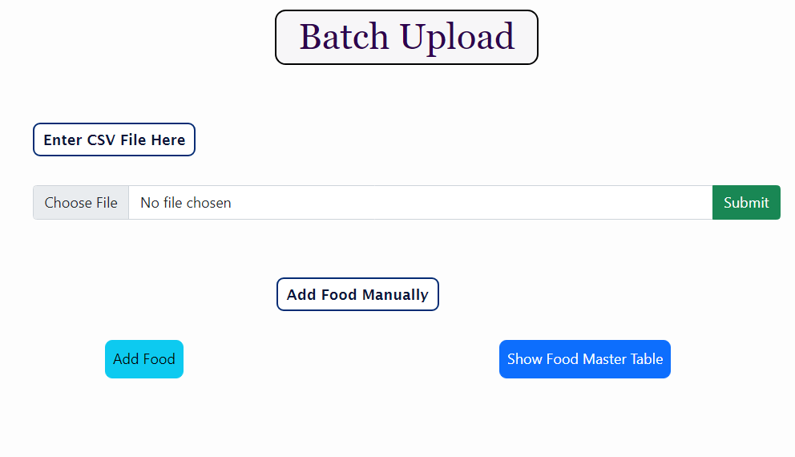

| **Method** | **Description** |
| --- | --- |
| “Batch Upload” | When “**Add New CSV File**” is clicked on **Food Master Table**, this webpage is shown. Several input fields are shown. |
| “Submit” button:- FoodIndex_new: file_to_db() | When **Submit** button is called, **file_to_db()** function is called and the file is added into the database. Identifies data from unique **Food ID**; if duplicate is present in file, it throws a warning. |
| “Add Food”:- FoodIndex_new: addfood() | When **Add Food** button is pressed, it redirects to the webpage for adding individual item. |
| “Show Food Master Table”:- FoodIndex_new(): base_table() | When “**Show Food Master Table”** is pressed, it redirects to **Food Master Table.** |

***Update Food Details***

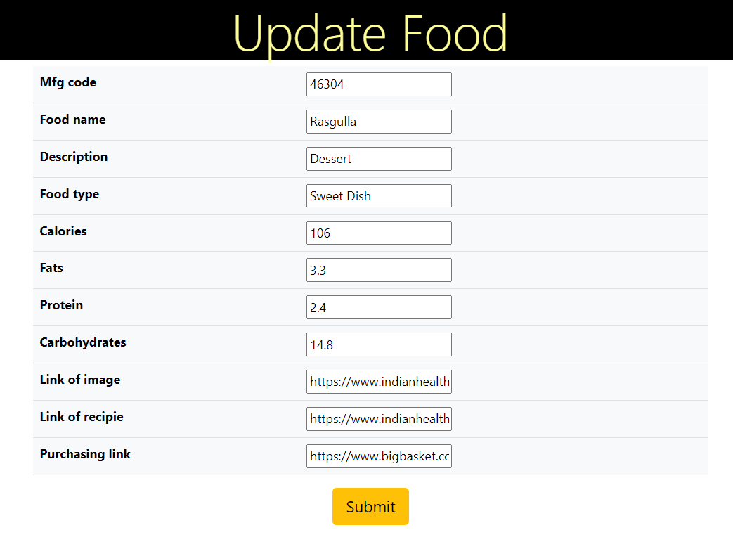

| **Method** | **Description** |
| --- | --- |
| “Update Food”:  Update_form.html | When “**Edit**” is clicked on **Food Master Table**, this webpage is shown by rendering update_form.html. Several input fields are shown.  All the fields which are allowed to modify can be modified from here. |
| “Submit” button:-  FoodIndex_new: update_food() | When “**Submit**” is clicked, the new data gets updates in the database and is immediately reflected in the **Food Master Table.** The food master table is rendered after submit. |

***Calories Analysis***

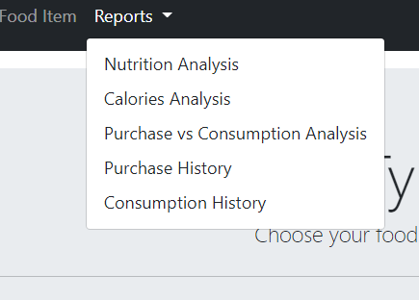

| **Method** | **Description** |
| --- | --- |
| Reports dropdown>>Calories Analysis  Home_app_new: userfoodlogchart() | Redirects to the **User Food Log Charts.**  The webpage has date inputs which shows calories consumption from dates recorded in database. |

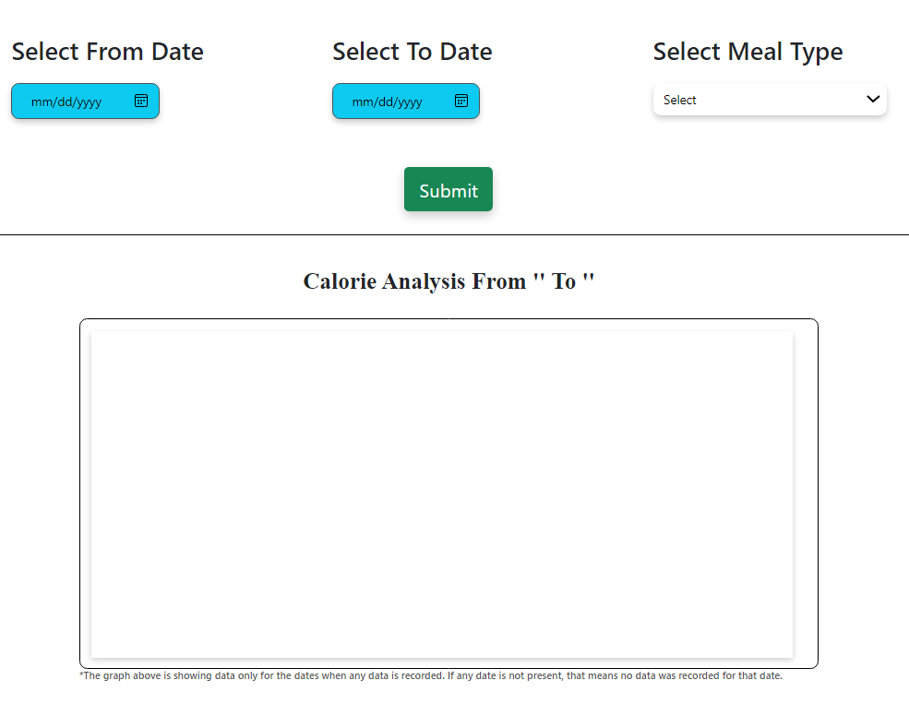

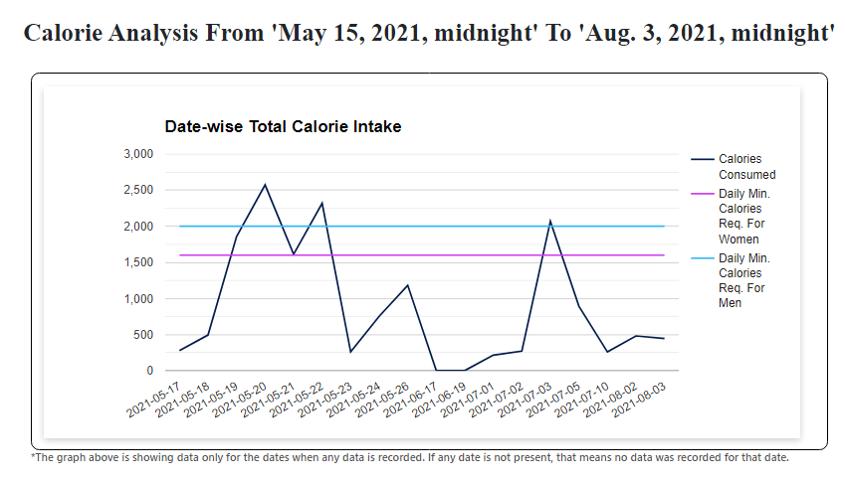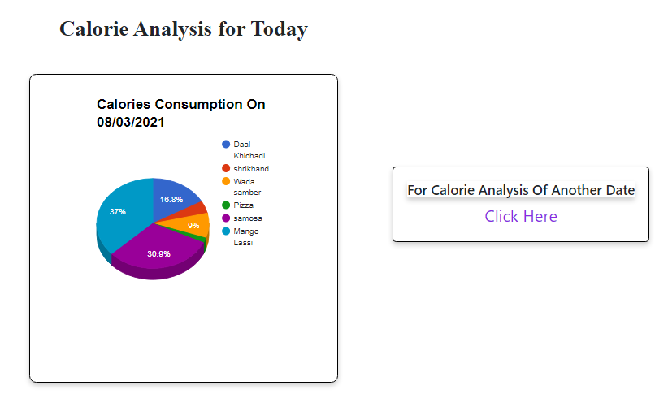

***Date-wise Calorie Analysis***

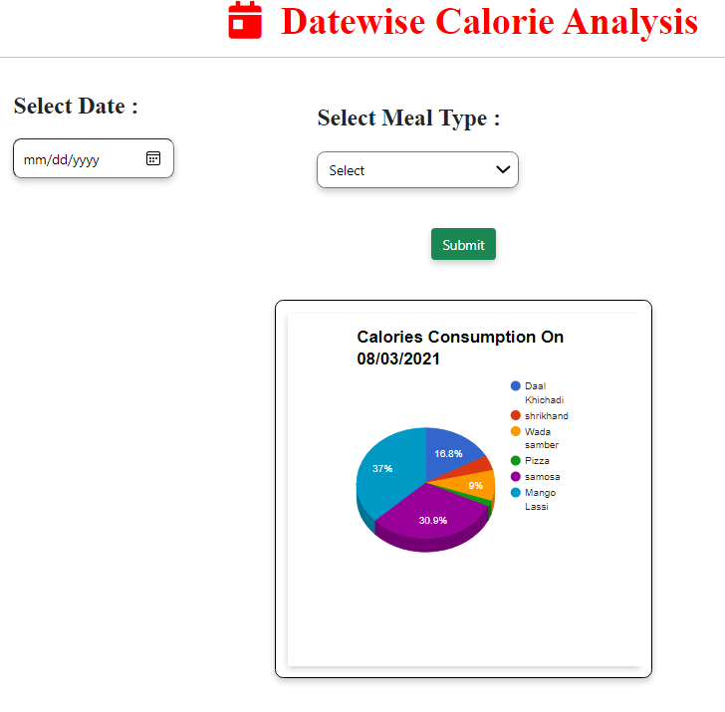

| **Method** | **Description** |
| --- | --- |
| “Submit” button: Home_app_new: userfoodlogchart()  userfoodlogchart.html | **Userfoodlogchart()** accepts input from “**Select From Date**”, “**Select To Date**” and “**Select Meal Type**”; when “**Submit**” button is pressed, a **line graph** is shown representing the calories consumption between the selected date range and selected meal type. Comparison with average calorie consumption for men and women is also shown. |
| “Calories Analysis for Today”:- Home_app_new: userfoodlogchart()  userfoodlogchart.html | In this block, a pie chart is shown which shows the distribution of calories consumed in present day divided between the consumed items. |
| “Calories Analysis of Another Date”:-  Home_app_new: otherdayanalysis()  Userdate_form.html | When “**Click Here**” is clicked, **userdate_form.html** is rendered and **Other Day Analysis** page is shown. It has **Select Date** input and **Select Meal Type** input. |
| “Submit” button: Home_app_new: otherdayanalysis()  userdate_form.html | **Otherdayanalysis()** function takes  **Select Date** input and **Select Meal Type** input and shows a **pie-chart** which shows the distribution of calories between the food consumed on the particular date. |

***Consume Comparison***

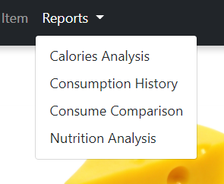

consumeComparison()

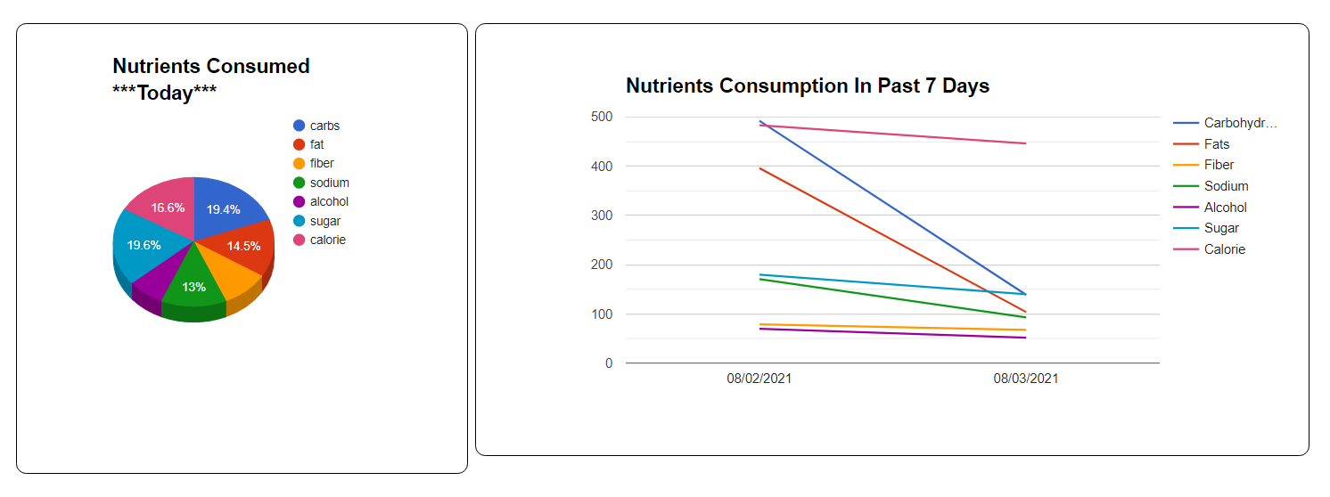

| **Method** | **Description** |
| --- | --- |
| Reports dropdown>>Consume Comparison  Home_app_new: consumeComparison()  consumeComparison.html | Redirects to the **Consume Comparison** page**.**  This page shows 2 analysis graphs. First graph is a **pie-chart** which shows distribution of quantities of nutrients consumed in **present day**. Second graph is a **line chart** which shows various **line graphs** representing nutrients consumed in the **recorded dates within the past 7 days.** |

***Purchase Comparison***

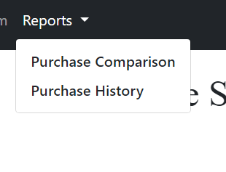

purchaseComparison()

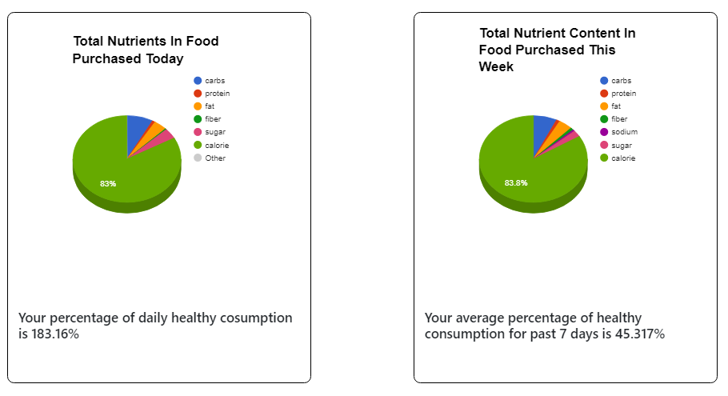

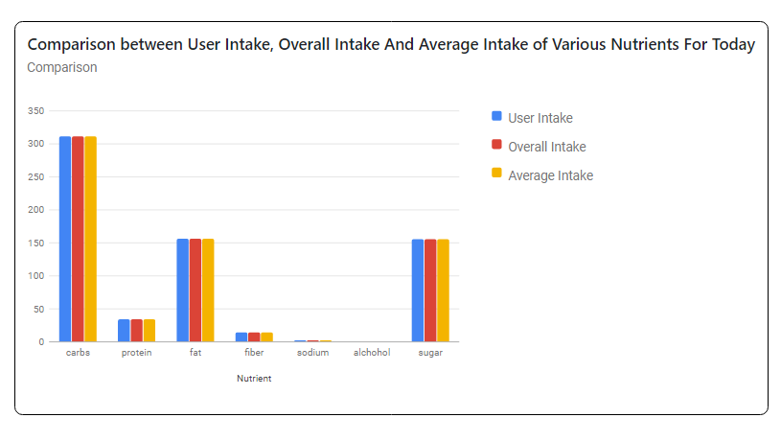

| **Method** | **Description** |
| --- | --- |
| Purchase Items>>Reports>>**Purchase Comparison**  **Home_app_new: purchaseComparison()**  **purchaseComparison.html** | When **Purchase Comparison** is clicked, it calls the **purchaseComparison()** function which renders the **purchaseComparison.html** file and redirects to Purchase Comparison page. This page has 3 graphs:   1. **Pie-chart** that shows nutrient wise distribution of food items purchased today. 2. **Pie-chart** that shows nutrient based distribution of food items purchased in last 7 recorded days. 3. A **bar graph** that shows comparison b/w **User Intake**, **Overall Intake** and **Average Intake** of nutrients for that particular day. |

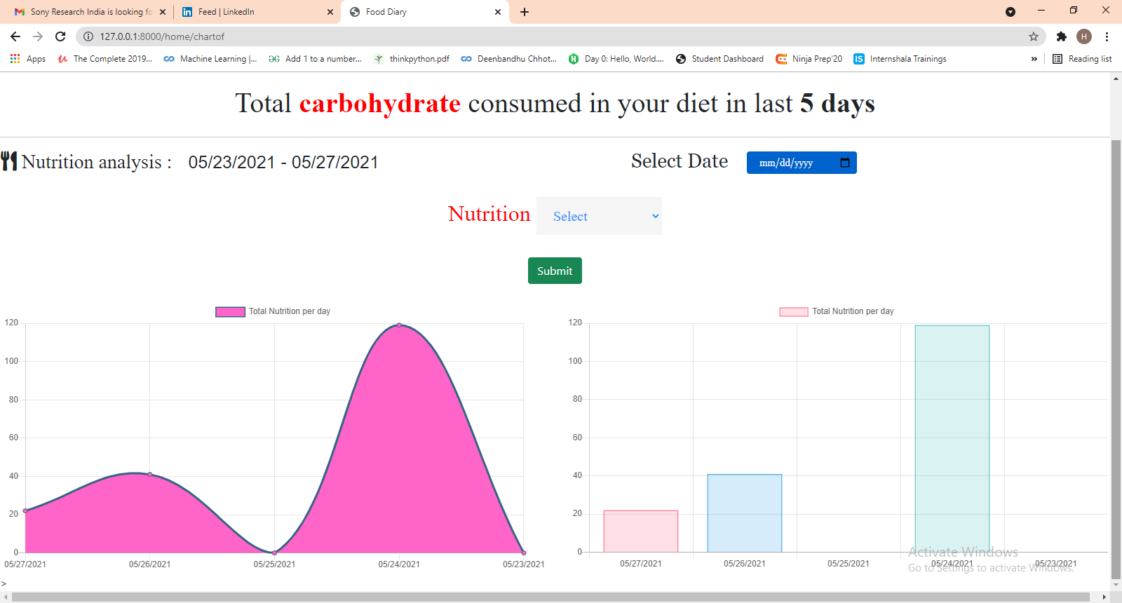

Class homeview

Class chartdata

Chartof()

|  |  |
| --- | --- |
| Method | Description |
| Chartof()  Templates file-Index.html  Views.py of home_app_new | In this function nuttype variable is used to get nutrition type input eg: carbohydrate,fats etc,.  Dateobj variable for taking dateinput .  With API userlogs from data is taken from date of dateinput to last 5 days.  User_log dataframe contains all the logs of that particular user.  From another api all the details of the food present in user_log dfataframe is extracted.  Sum them and pass the list to html page |
| HomeView,Chartdata  Templates file-Index.html  Views.py of home_app_new | Used to present the above the chart |

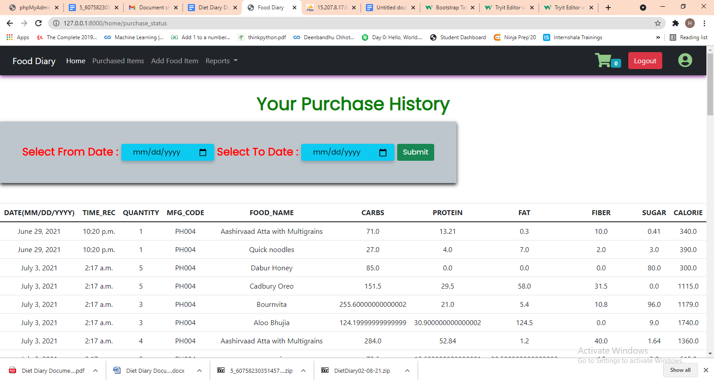

Purchase_status()

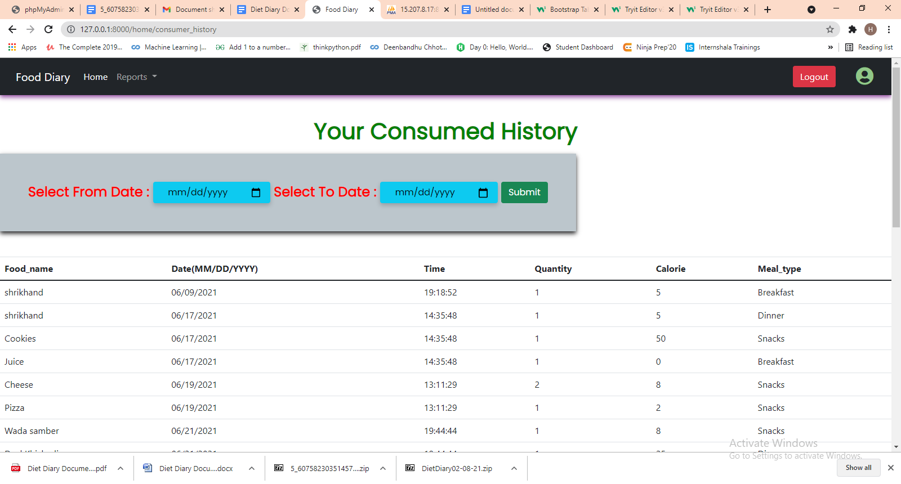

Consumer_history()

|  |  |
| --- | --- |
| Method | Description |
| Purchase_status()  Home_app_view  Purchase_status.html | Select_from and select_to are used to take date inputs  This function extracts the data from the database and gives the output in the form of dataframe and in the html file it converts dataframe to table |
| Cosumer_history ()  Home_app_view  Consumer_history.html | Userlog API is called and inputs are passed in that API after that all the content extracted from the API is converted into dataframe format after that the dataframe is passed into consumer_history.html file |

context_preprocessors.py (API folder)-For Navbar

|  |  |
| --- | --- |
| Items_left |  |
| Purchase_left |  |
| Assorted_left |  |